**Assignment 5.3**

**Data set:**

We have a dataset of movie data analysis Column Name:

Column 1: User ID

Column 2: Movie ID

Column 3: Rating

Column 4: Time stamp

The input file can be downloaded from the below link

Movie data analysis

**Problem Statement 1:**

Find the number of ratings given by each user.

**Problem Statement 2:**

Find the number of ratings received by each movie.

**Program:**

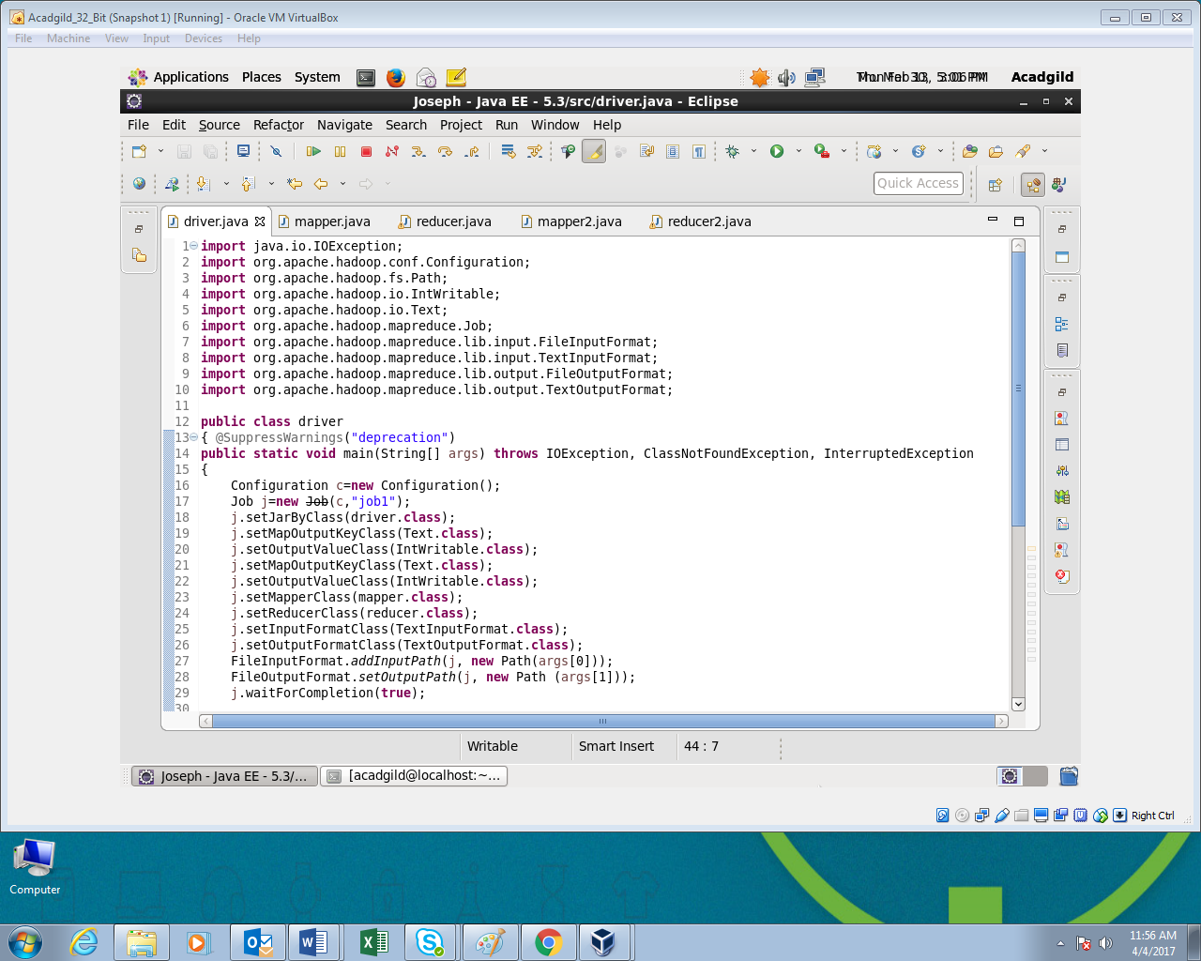

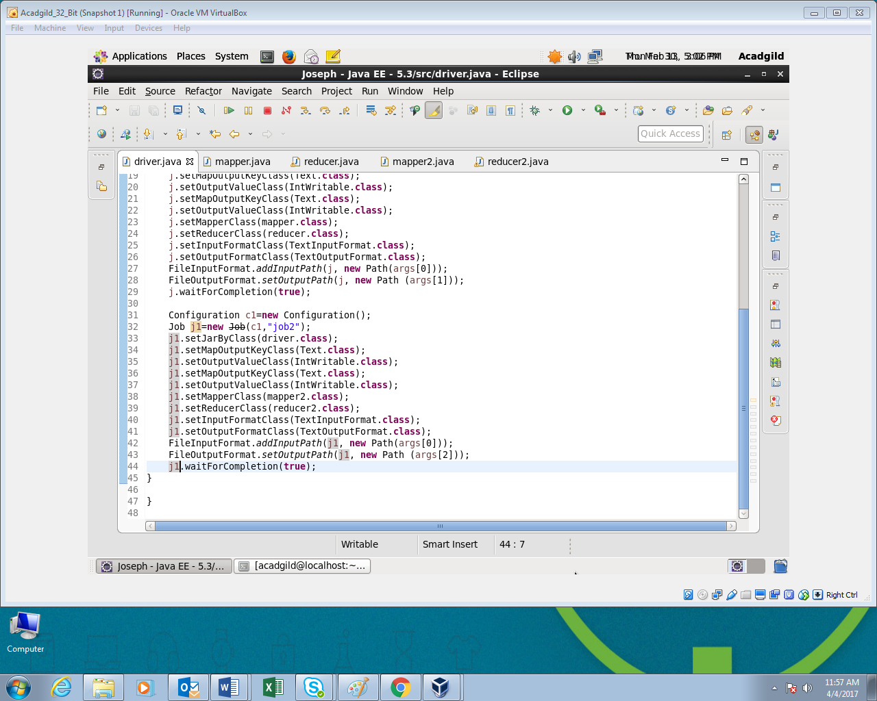

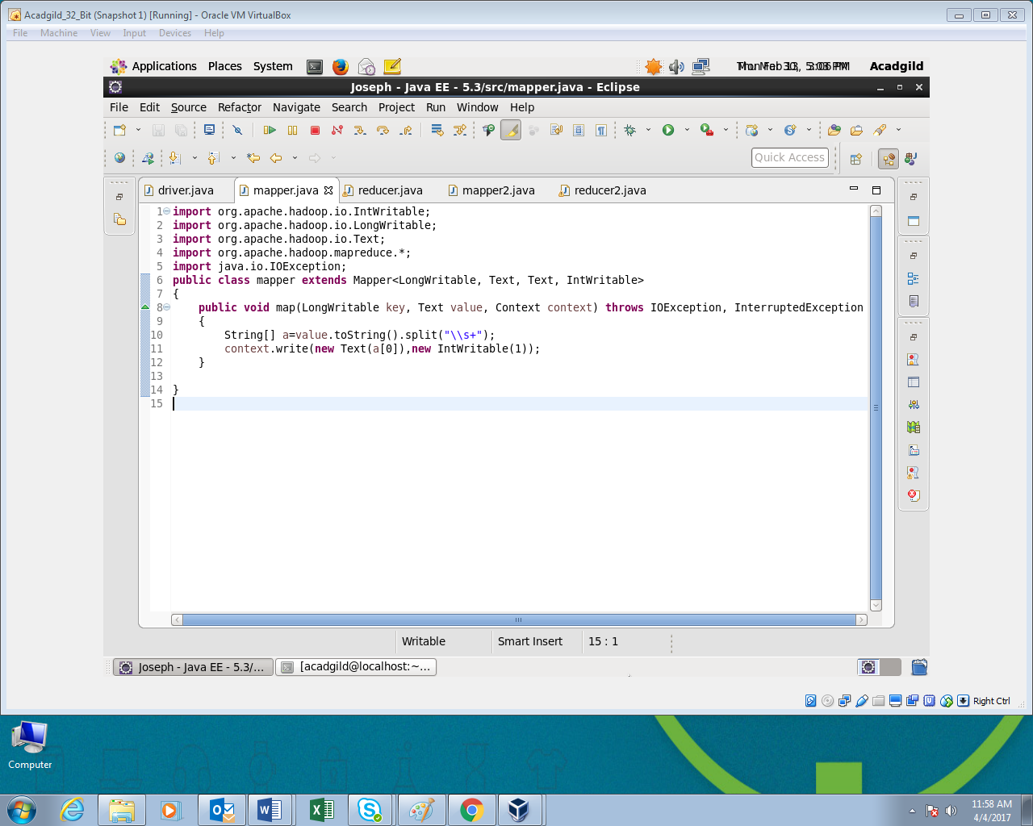

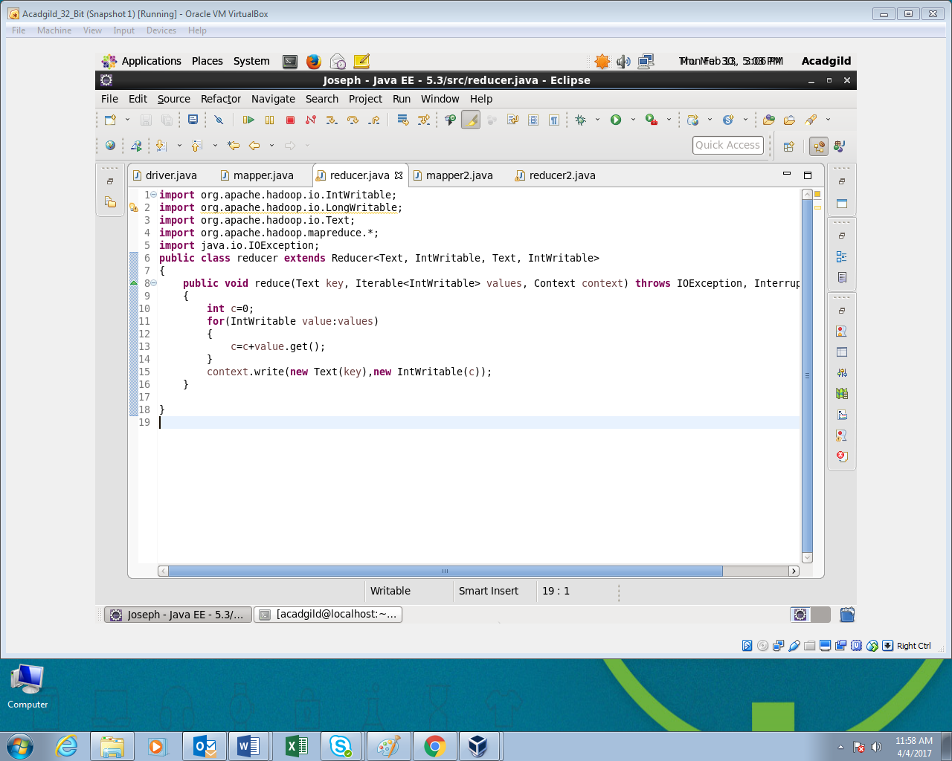

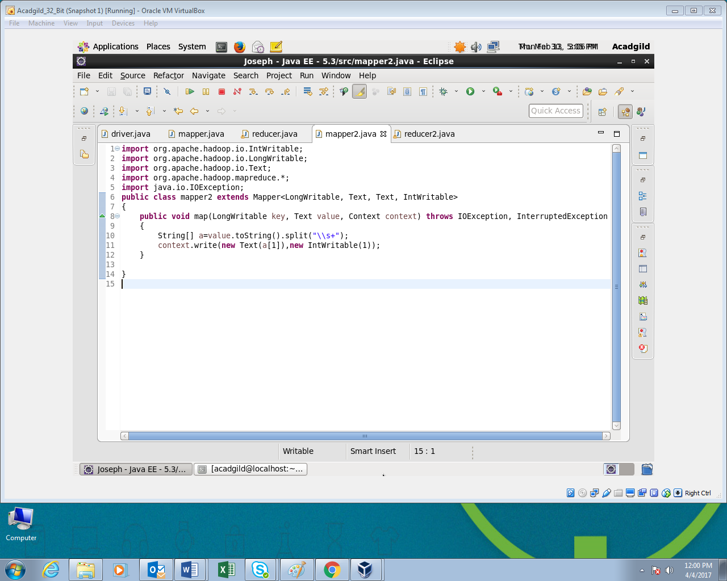

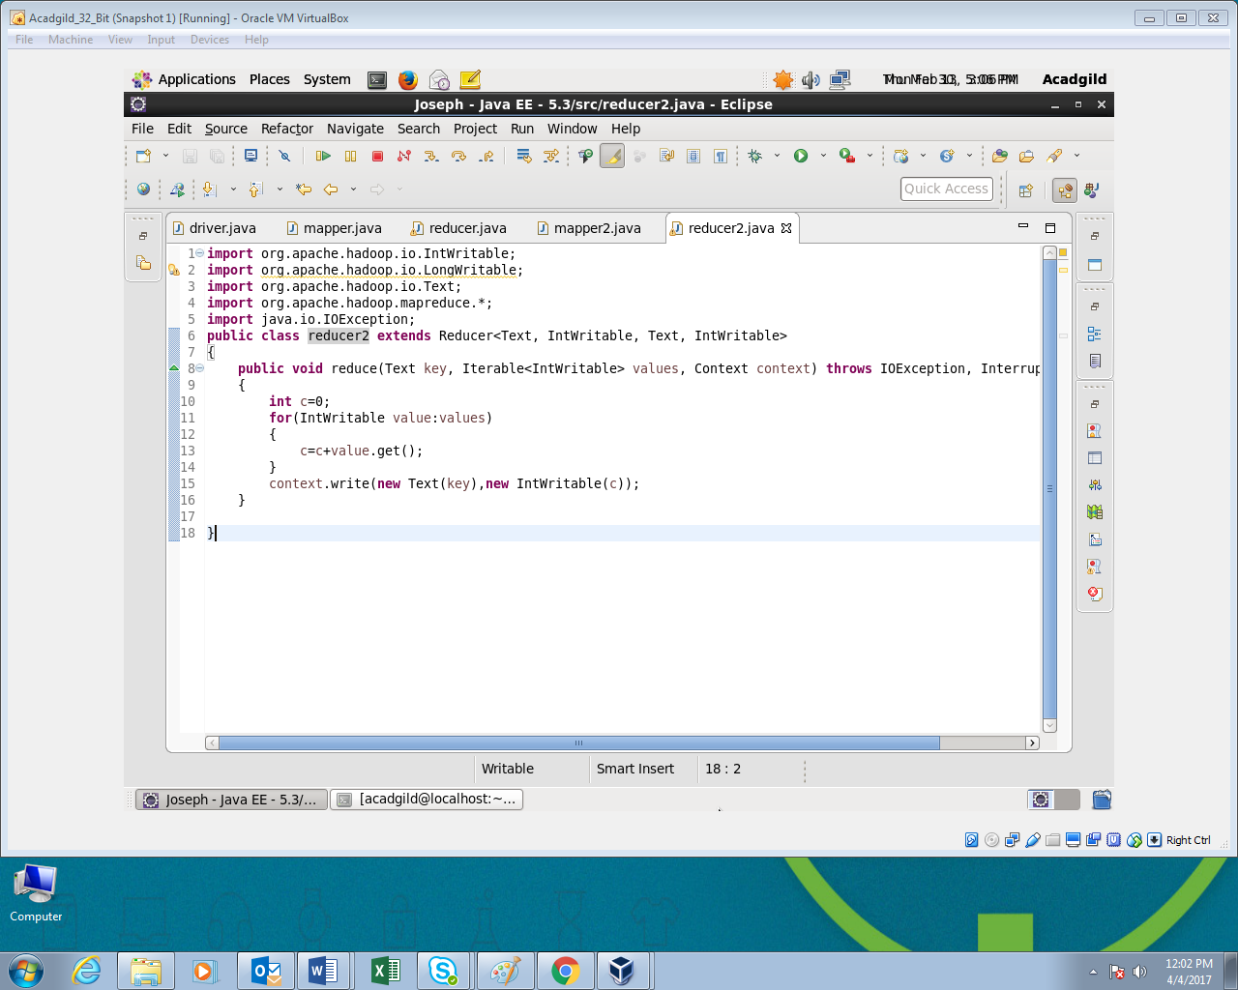

**Output:**

